Step 1: Created a Dockerfile for NGINX image without using the official image.

**Instructions in Dockerfile:**

FROM ubuntu:16.04

MAINTAINER Panthamajay

RUN apt-get update

RUN apt-get install nginx -y

COPY index.html /usr/share/nginx/html/

EXPOSE 8080

CMD ["nginx","-g","daemon off;"]

1. Changed the pwd to directory where dockerfile is saved & Created a nginx image by running the command

$ sudo docker build -t image .

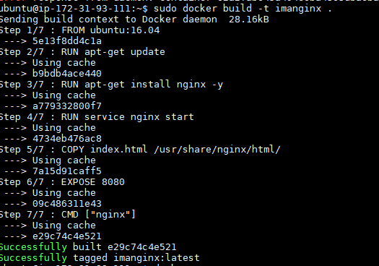

3.Created a container from the nginx image using command

$ sudo docker run -d -p 8080:8080 image



After running a container from the build image with 8080 as publish port, a nginx server gets installed into our image

We can verify it by running http:// my ip:8080 in web browser

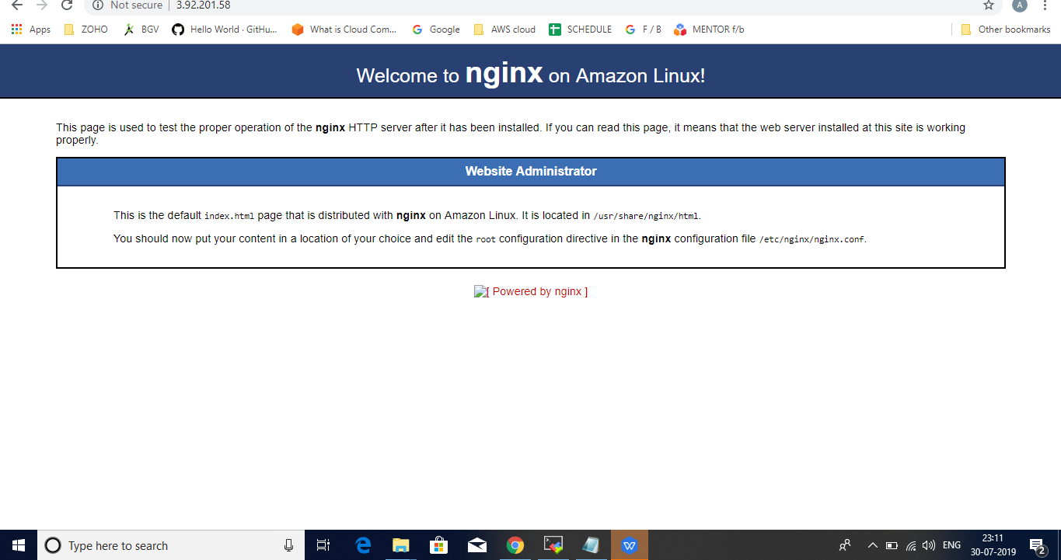

1. When we run a container from image, we get an id

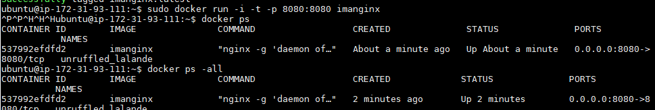

1. Executed a bash on container by using the container id.

docker exec -it <container name> /bin/bash

1. Then run coomand as below to install nano

docker exec -it <container name> <sudo apt install nano>

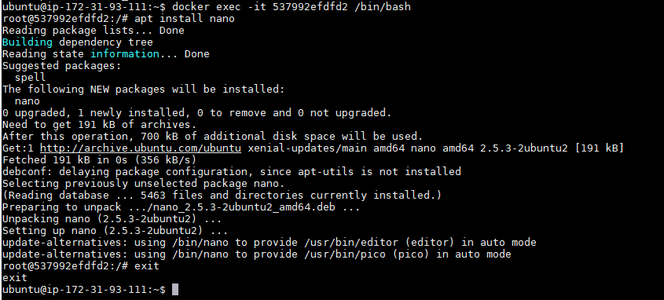

**PUSHING IMAGE TO DOCKER REGISTRY:**

Logged into docker hub

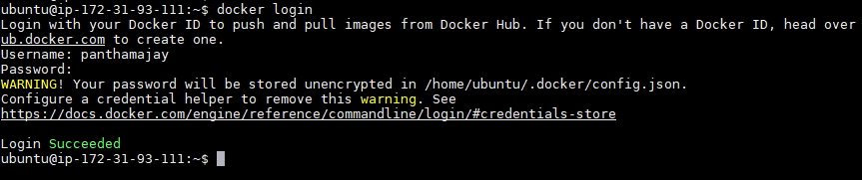

Tagged the image and then pushed the image into docker hub.

$ docker tag imageid username/repo name:tagname

$ docker push username/repo. name

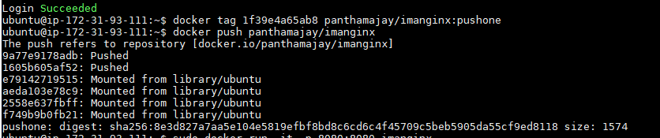

The image with its tag has successfully pushed into docker hub.

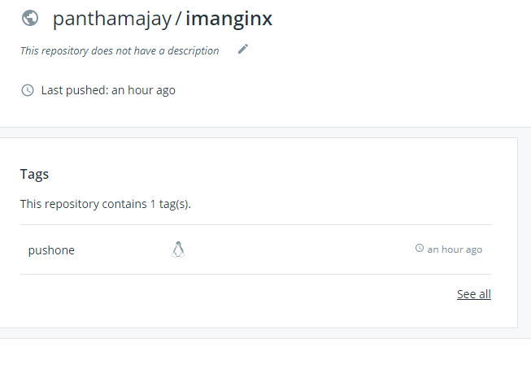

**Pushing image to ECR:**

1. Attached IAM role for ec2 instance to access ECR and then created a repository through CLI.

aws ecr create-repository --repository-name new-latest --region us-east-1

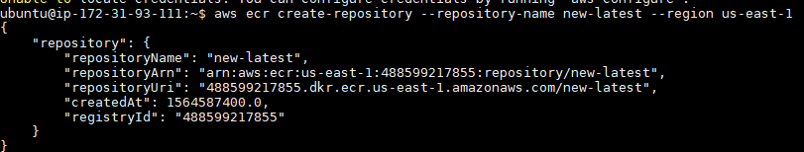

1. Used the more long-winded auth. mechanism to get the authorization token

for logging into AWS

aws ecr get-authorization-token --region us-east-1 --output text \

--query authorizationData[].authorizationToken | base64 -d | cut -d: -f2

1. Copied the above got key and used it as password for logging into AWS from docker.

docker login -u AWS

<https://488599217855.dkr.ecr.us-east-1.amazonaws.com/new-latest>

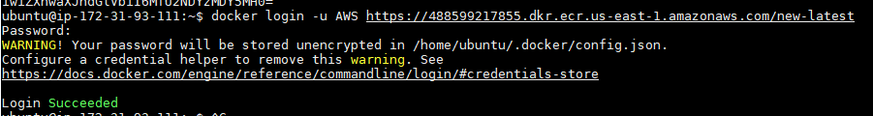

1. Tagged the image and then pushed the image into AWS ECR

docker tag imageid 488599217855.dkr.ecr.us-east-1.amazonaws.com/new-latest

docker push 488599217855.dkr.ecr.us-east-1.amazonaws.com/new-latest

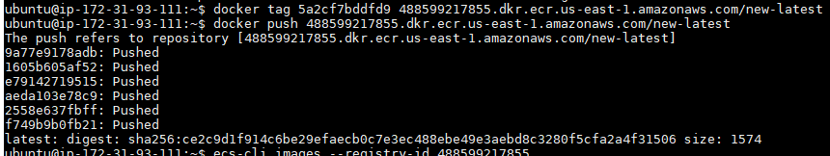

The image got pushed into AWS ECR. using CLI listed the repositories created in ECR.

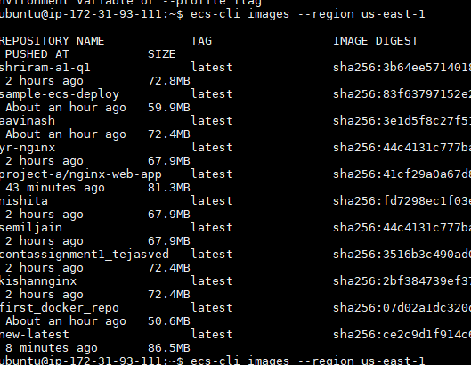

My repository is new-latest

**Pushing image to GCR:**

1. Installed gcloud sdk on ec2 instance.
2. Configured and given credentials such that the instance can access the GCR
3. Inorder to push the local image to container registry, tagged image with registry name

docker tag imageid gcr.io/pe-training/gcrpushone

1. Pushed the image using command

docker push gcr.io/pe-training/gcrpushone

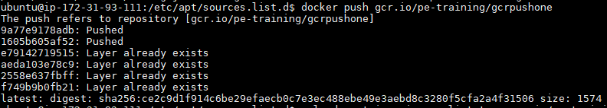

Listing pushed image from CLI



In container registry:

